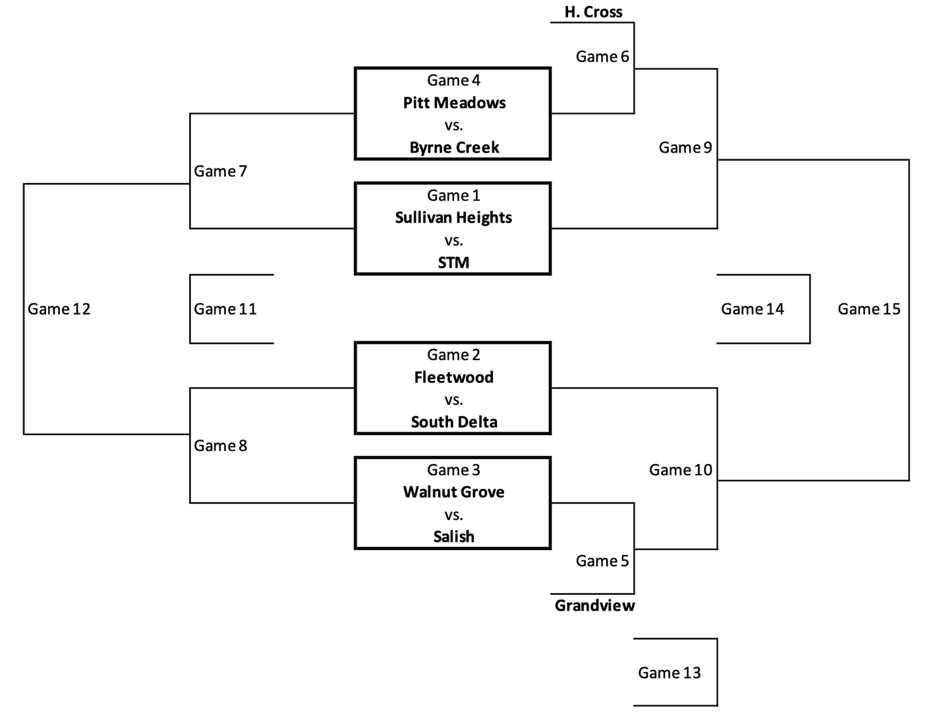
Thursday January 11
Game #1 – 12:00 Sullivan Heights vs STM
Game #2 – 1:15 Fleetwood vs. South Delta
Top team listed is the Home Team White
Game #3 – 2:30 Walnut Grove vs Salish
Game #4 – 3:45 Pitt Meadows vs Byrne Creek
Game #5 – 5:00 Grandview vs WG3
Game #6 – 6:15 WG4 vs Holy Cross

Friday January 12
*Game #7 – 12:00 LG1 vs LG4
Game #8 – 1:15 LG2 vs LG3
*Game #9 – 2:30 WG1 vs. WG6
Game #10 – 3:45 WG2 vs WG5

*Note: Game 9 will swap gametimes with Game 7 if Sullivan wins Game 1

Saturday January 13
Game #11 – 9:00 LG7 vs LG8
Game #12 – 10:15 WG7 vs WG8
Game #13 – 11:30 LG5 vs. LG6
Game #14 – 12:45 LG9 vs. LG10
Game #15 – 2:00 WG9 vs. WG10

